**9University of Westminster – School of CS&E**

| **Web Design and Development**  **Coursework Specification (2023/24)** | |
| --- | --- |
| Module leader | Dr Daphne Economou |
| Unit | Group Coursework – Website Design and Development |
| Weighting: | 50% |
| Qualifying mark | 30% |
| Description | Group Coursework |
| Learning Outcomes Covered in this Assignment: | The coursework rationale is:  LO1: Utilise a text editor to create several linked HTML documents, following certain style guidelines and satisfying a simple specification;  LO2: Identify and apply how to separate the structure, behaviour and presentation of web documents;  LO3: Incorporate and develop JavaScript to create interactive documents;  LO4: Work in a group, with each individual having a distinct role and tasks, to produce a common Web site. |
| Handed Out: | 20 February 2024 |
| Due Date: | **2 April 2024 at 13:00 pm** |
| Expected deliverables: | * Implementation of assigned Web Pages in the group project (as per team member allocation) * Individual Report * In-Class Demonstration |
| Method of Submission: | * The submission is via Blackboard. * Your individual report submitted as a single PDF or Word document. Your report should contain a copy of the HTML, CSS and JavaScript that you developed for your tasks (this will be submitted to Turnitin). * Your individual webpages (HTML/CSS/JavaScript).   Blackboard will require that you zip your html files into one folder to upload |
| Type of Feedback and Due Date: | Verbal feedback at the coursework demonstration.  Written feedback and marks 15 working days after the submission deadline.  Marks will remain provisional until formally agreed by an Assessment Board. |

# 

Contents

1. Assessment regulations 3

2. Penalty for Late Submission 3

3. Coursework Description 4

3.1 Website design & development 4

3.1.1 Splash Screen: Assigned to [](#_Toc159314418)**[Student 1](#_Toc159314418)**[] 5

3.1.2 Home Page + website template + navigation bar: Assigned to [](#_Toc159314419)**[Student 2](#_Toc159314419)**[] 5

3.1.3 Gallery: Assigned to [](#_Toc159314420)**[Student 4](#_Toc159314420)**[] 7

3.1.4 Shop: Assigned to [Student 1] 8

3.1.5 User Profile: Assigned to [](#_Toc159314422)**[Student 3](#_Toc159314422)**[] 10

3.1.6 Feedback: Assigned to [](#_Toc159314423)**[Student 2](#_Toc159314423)**[] 12

3.1.7 Sitemap: Assigned to [](#_Toc159314424)**[Student 4](#_Toc159314424)**[] 13

3.1.8 Team: Assigned to [](#_Toc159314425)**[Student 3](#_Toc159314425)**[] 14

3.1.9 Content page: Assigned to [](#_Toc159314426)**[all Students](#_Toc159314426)**[] 15

3.1.10 Page Editor: Assigned to [](#_Toc159314427)**[all Students](#_Toc159314427)**[] 17

3.1.11 Additional JavaScript [](#_Toc159314428)**[all students](#_Toc159314428)**[] 17

3.1.12 General coursework requirements [](#_Toc159314429)**[all students](#_Toc159314429)**[] 18

3.1.13 Website folder structure, file naming [](#_Toc159314430)**[all students](#_Toc159314430)**[] 18

3.1.14 Contribution to Group Meetings 19

3.2 Individual Report 19

3.3 In-class demonstration 19

**4.****Coursework Submission** 20

4.1 Step 1 - Website submission 20

4.2 Step 2 - Report submission 20

5. Marking scheme 20

# Assessment regulations

Refer to the following for clarification on what constitutes plagiarism:

<https://www.westminster.ac.uk/current-students/guides-and-policies/academic-matters/academic-misconduct/plagiarism>

Clarification on what constitutes collusion:

<https://www.westminster.ac.uk/current-students/guides-and-policies/academic-matters/academic-misconduct/collusion>

# Penalty for Late Submission

If you submit your coursework late but within 24 hours or one working day of the specified deadline, 10 marks will be deducted from the final mark, as a penalty for late submission, except for work which obtains a mark in the range 40 – 49%, in which case the mark will be capped at the pass mark (40%). If you submit your coursework more than 24 hours or more than one working day after the specified deadline you will be given a mark of zero for the work in question unless a claim of Mitigating Circumstances has been submitted and accepted as valid.

It is recognised that on occasion, illness or a personal crisis can mean that you fail to submit a piece of work on time. In such cases you must inform the Campus Office in writing on a mitigating circumstances form, giving the reason for your late or non-submission. You must provide relevant documentary evidence with the form. This information will be reported to the relevant Assessment Board that will decide whether the mark of zero shall stand. For more detailed information regarding University Assessment Regulations, please refer to the following website:

<http://www.westminster.ac.uk/study/current-students/resources/academic-regulations>

# Coursework Description

This coursework requires the following deliverables:

* The **design & development of a** **website** as a group project, with each team member assigned specific tasks
* **Individual Report**
* **In-Class Demonstration**

This document offers a detailed description of the requirements for each of these deliverables.

## 3.1 Website design & development

***“****Our [Being Westminster strategy](https://www.westminster.ac.uk/about-us/our-university/vision-mission-and-values/sustainable-development) outlines our commitment to being progressive, compassionate and responsible to help students and colleagues from different backgrounds fulfil their potential and contribute to a more sustainable, equitable and healthier society.*

*We adopted the [United Nations Sustainable Development Goals (SDGs)](https://sdgs.un.org/goals) framework to support this core mission and to record, measure and improve our contribution to a range of social, environmental and economic outcomes.****”***

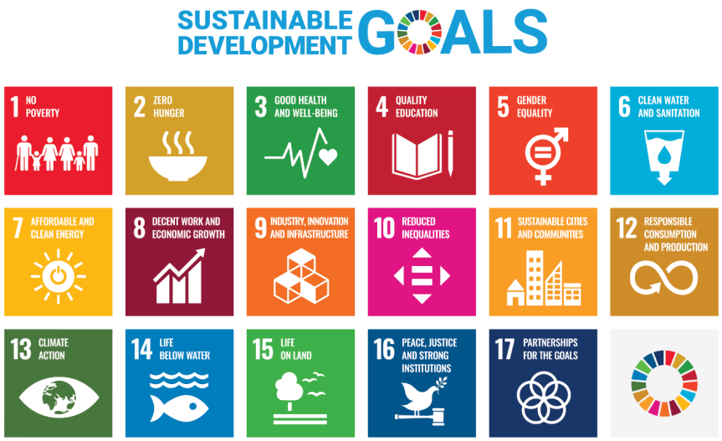

**Figure 1.** United Nations Sustainable Development Goals (SDGs)

Work in groups of 4 students (all group members should be from the same Web Design and Development computer seminar group) **and design and develop a web site that focuses on** **introducing 1 of the 17** United Nations Sustainable Development Goals (SDGs)**.**

The website must include the following main pages, with each group member assigned to develop specific components as outlined below:

1. **Splash Screen** Assigned to [**Student 1**]
2. **Home Page *+ template + nav*** Assigned to [**Student 2**]
3. **Gallery** Assigned to [**Student 4**]
4. **Shop** Assigned to [**Student 1**]
5. **User Profile** Assigned to [**Student 3**]
6. **Feedback** Assigned to [**Student 2**]
7. **Sitemap** Assigned to [**Student 4**]
8. **Team** Assigned to [**Student 3**]
9. **Content page** Assigned to [**all Students**]
10. **Page Editor** Assigned to [**all Students**]

While team members are assigned specific tasks to implement, it's essential for the group to collaborate in deciding the website's content and overall look and feel.

The technical requirements for each of these pages are detailed in the following sections.

### 3.1.1 Splash Screen: Assigned to [**Student 1**]

The splash screen page should include the following elements:

* **Website mission**
* **Group members**
* **Redirection**
* **Loader image**

The splash screen should prominently feature the website title and mission along with the names of the group members. It functions as a splash screen, providing an initial introduction to the site. After a brief duration of 4 seconds, it automatically redirects users to the Home page, ensuring a seamless transition into the main content. The splash screen could contain an animated image indicating that the home page is loading.

### 3.1.2 Home Page + website template + navigation bar: Assigned to [**Student 2**]

The home page should include the following elements:

* **Website Identity (Logo)**
* **Website Mission**
* **Navigation Bar**
* **Links to content**

The Home page should prominently feature the **logo** of the website to establish its identity.

The Home page should elaborate on the UN Sustainable Development Goal that the website is aligned with, conveying its purpose and commitment to sustainability.

Navigation Bar should facilitate seamless navigation to other sections of the website. The navigation bar will be designed using CSS indicating the active page being browsed by the user and featuring a hover effect to highlight available links, as illustrated in Figure 2. The CSS styling may entail rendering links as buttons or incorporating a bottom border effect. We recommend using a class to denote the **active page**.

**Figure 2.** Navbar with Hover Effect and Active Page Indication

**The navigation bar will initially be created by Student 2 as part of the home page development. However, it's essential for all students to adapt and include this navigation bar on all other pages throughout the website to ensure a consistent look and feel. Student 2 is also responsible for creating an external CSS file that ensures a common look and feel for the website.**

The home page should also include Links to the 4 pages of the website dedicated to content (see section 1.9). This could look like a gallery like Figure 1, or Figure 3 below.

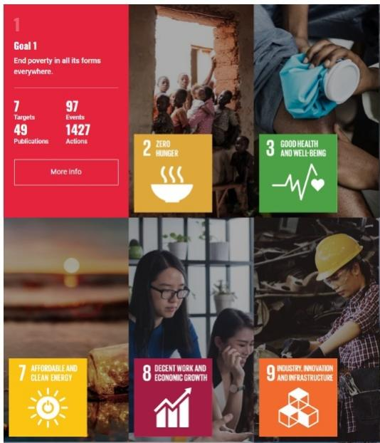

**Figure 3.** A snapshot of the <https://sdgs.un.org/goals> home page with interactive tiles that provide details about each sustainability goal and are links to a page with more information about it.

The navbar could possibly a part of the website header (as in Figure 4). Student 2 will also create an external **CSS file that establishes a unified template for the website**. This may include a standardized header featuring the website identity (potentially incorporating a logo), a footer where each team member can include a link to their page editor, and general page styling. All team members will have to use this template and navigation bar to ensure a consistent look and feel of the website.



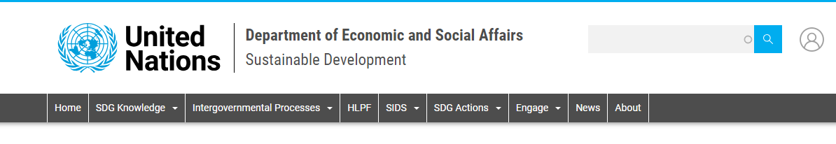

**Figure 4.** Two example headers that include information about the website identity combined with the navigation bar.

### 3.1.3 Gallery: Assigned to [**Student 4**]

The gallery page should include the following elements:

* **Interactive thumbnails**
* **Extended details of thumbnails**
* **Customization of page colour, font style**

Create a gallery page designed for engaging user experience allowing users to explore images and content relevant to your website's theme. Construct the HTML structure for each thumbnail image and its corresponding extended view as shown in the examples in Figure 5. Integrate the following interactivity to the thumbnails:

* when a user hovers over a thumbnail image, it should visually indicate that it's clickable, inviting interaction
* upon clicking a thumbnail, it should expand to reveal an extended view with more detailed content
* the extended view should display a larger version of the thumbnail image and include a detailed description associated with the image content (like the game of the year example of Figure 4), this could also popup.

All images and descriptions should have appropriate alternative text for accessibility.

Provide users with the ability to customize the colour scheme and font within the extended view for enhanced personalization.

***

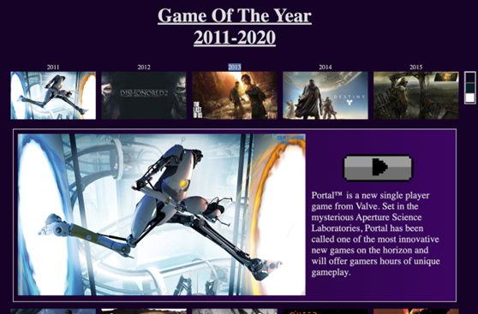

**Figure 5.** Gallery pages examples

### 3.1.4 Shop: Assigned to [Student 1]

The shop page should include the following elements:

* **Product showcase**
* **Product options**
* **Product selection**
* **Order summary (basket)**
* **Checkout summary**
* **Checkout system feedback**

The product showcase features a well-organized layout, showcasing product images, titles, descriptions, and prices where users can browse, and purchase products related to the theme of the website (it could be products for fundraising for the UN sustainability goal your website is about). The design ensures a smooth and intuitive shopping experience, with clear navigation and visually appealing product displays (see Figures 6 and 7).

The users should be able to customize the product purchase (e.g. product size, colour, other options).

Each product listing includes an "Add to Cart" button, allowing users to select items they wish to purchase.

The order summary (basket) captures information about the selected products (the list of the selected items, like thumbnails of the product added to the order, quantity, total).

To proceed to checkout, users must select at least one product. A validation message prompts users to select items if they attempt to proceed without making a selection.

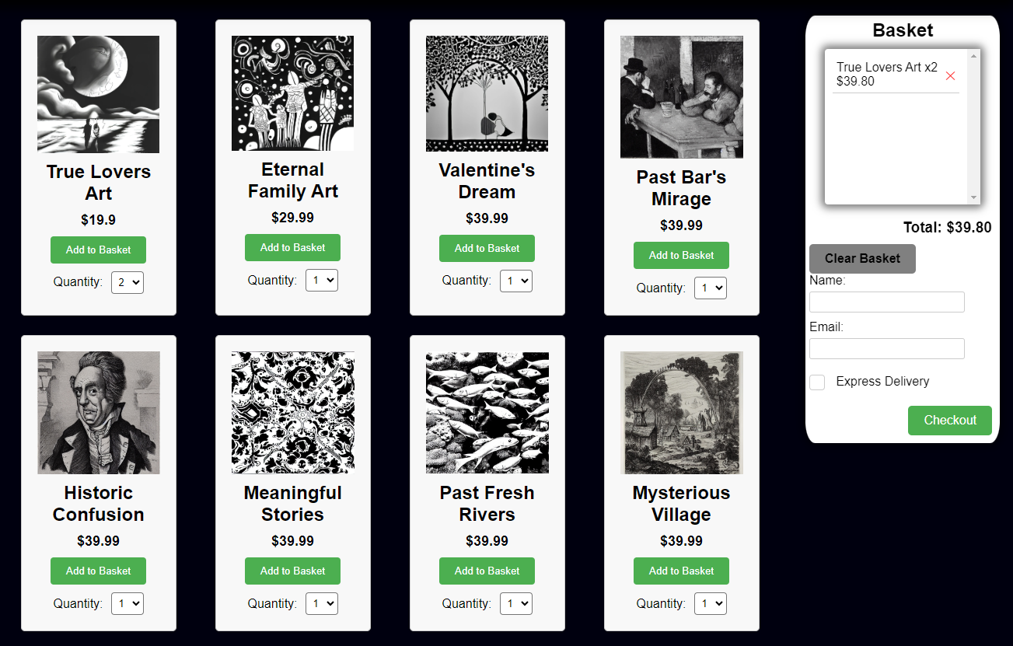

**Figure 6.** A product showcase example

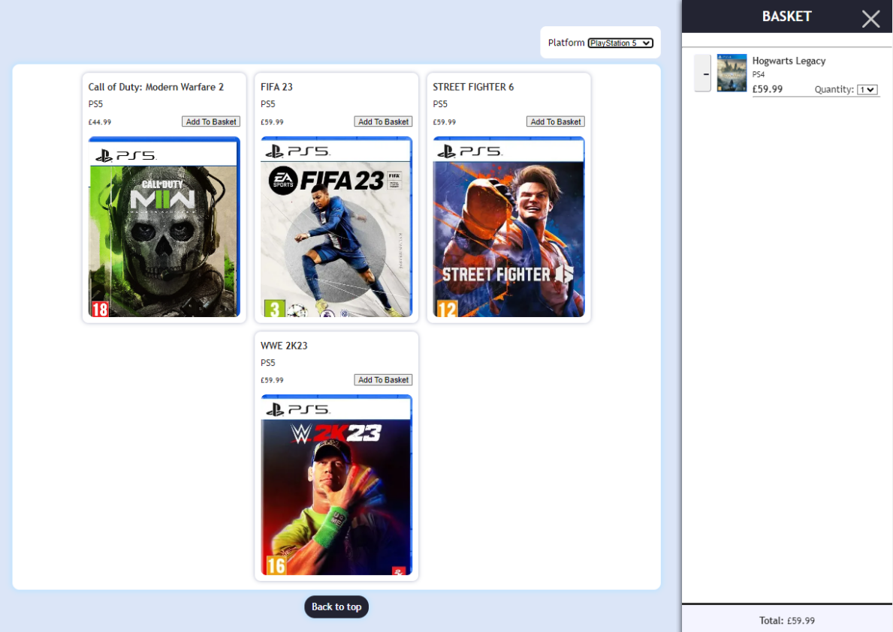

**Figure 7.** A product showcase example that allows product filtering and the basket includes a picture of the product

The checkout section is where users finalize their purchases and provide necessary information for order processing like their personal details, contact information, and shipping address (see Figure 8).

Mandatory fields are clearly indicated, ensuring users provide essential information to complete the order. The form includes validation checks to verify that required fields are filled in correctly. Incorrectly filled fields are highlighted to prompt users for correction.

Once all required information is provided and validated, users can proceed to complete their purchase.

The system provides a message to confirm the completion of the order.

The design prioritizes simplicity, guiding users through each step of the checkout process with clear instructions and feedback.

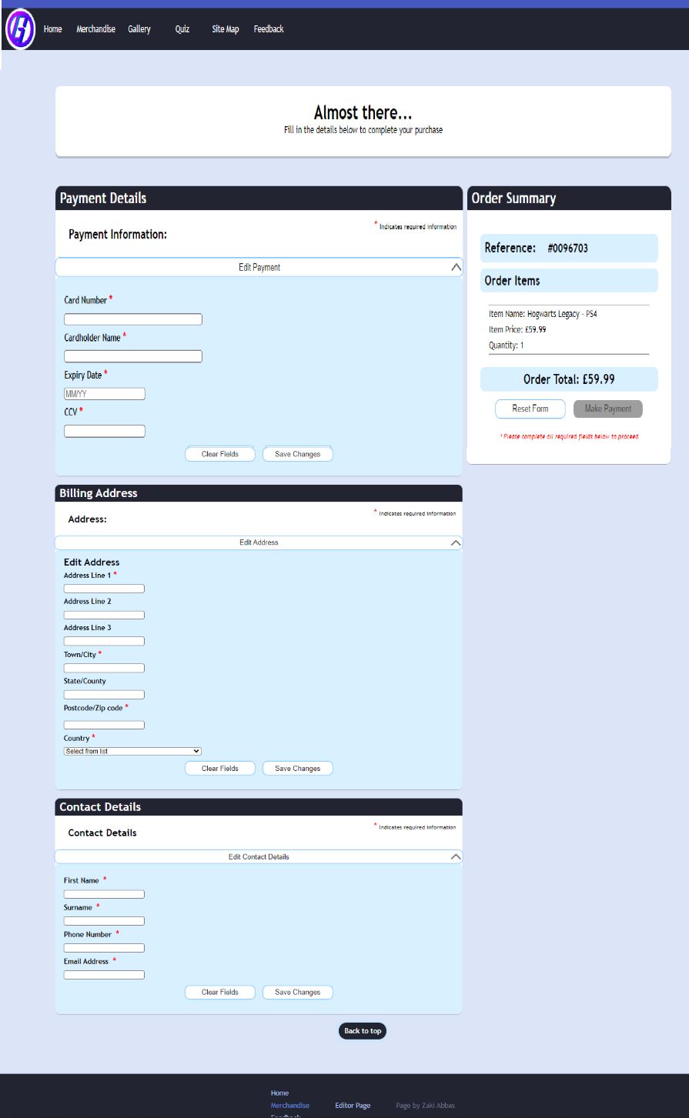

**Figure 8.** A product checkout example

### 3.1.5 User Profile: Assigned to [**Student 3**]

The user profile page should include the following elements:

* **Prompts to collect the user information**
* **Progressive display of user output**
* **Progress completion**
* **Feedback and confirmation**

Building a user profile progressively involves guiding users through a series of prompts to collect their information gradually and providing feedback for profile level of completion as shown in Figure 9. Here's a description of how this process could be implemented:

The system presents users with **prompts**, asking for basic information such as their name or username (**use prompts not a form**). Each prompt is designed to be concise and clear, guiding users through the process in a step-by-step manner. The prompts may cover various aspects such as personal details, preferences, interests, or any other relevant information required to build a comprehensive user profile relevant to the theme of the website you design.

The prompts are organised in categories, such as personal details, tasks, qualifications, other (depending on the theme of the website you design)

The progressive profile form should be built by at least 12 prompts and 3 steps.

**Figure 9**. Progressive user profile building with prompts categorised in 4 steps

As users provide their information, the system progressively updates and **displays their user profile** (in some short of profile output area as shown in Figure 8). Initially, only basic details are shown, such as their name or username. As users provide each piece of information, the system dynamically adjusts and displays subsequent prompts based on their previous responses.

The system also provides **feedback on the profile completion progress** ranging from a minimum level of completion for the first set of prompts to 100% completion for having completed all the steps.

Users should have full control over the information they choose to provide and can opt to **skip certain prompts** **or steps** in the profile completion process. This flexibility should be reflected in both the displayed information of the user profile and the progress indicator for the profile completion process.

Additionally, users should have the option to return to and complete any steps they initially skipped. This allows them to gradually enrich their profile with more detailed information, reflecting their preferences, interests, and other relevant data.

### 3.1.6 Feedback: Assigned to [**Student 2**]

The feedback form page should feature a clean and intuitive interface, making it easy for users to navigate and submit their comments (see Figures 10) that includes the following elements:

* **Input fields**
* **Validation**
* **Error handling**
* **Preview**
* **Edit**
* **Confirmation**

Include **input fields** for users to enter their name, email (optional or mandatory based on requirements), rating and their comment or message. Optionally, include additional fields such as a subject line or category selection to categorize comments.

The form should be set up to email the contents of the form to a valid email address (during the demo you will need to demonstrate that this feature works).

Implement **validation** checks to:

* ensure that email input is in the correct format
* ensure that required fields are completed before submitting the form.

Provide clear **error** messages and indications if users attempt to submit the form with missing or invalid information. Highlight the fields that require attention to assist users in correcting their input.

Allow users to **preview** the feedback form and **edit** it before submitting it.

Upon successful submission, display a **confirmation** message to acknowledge receipt of the comment.

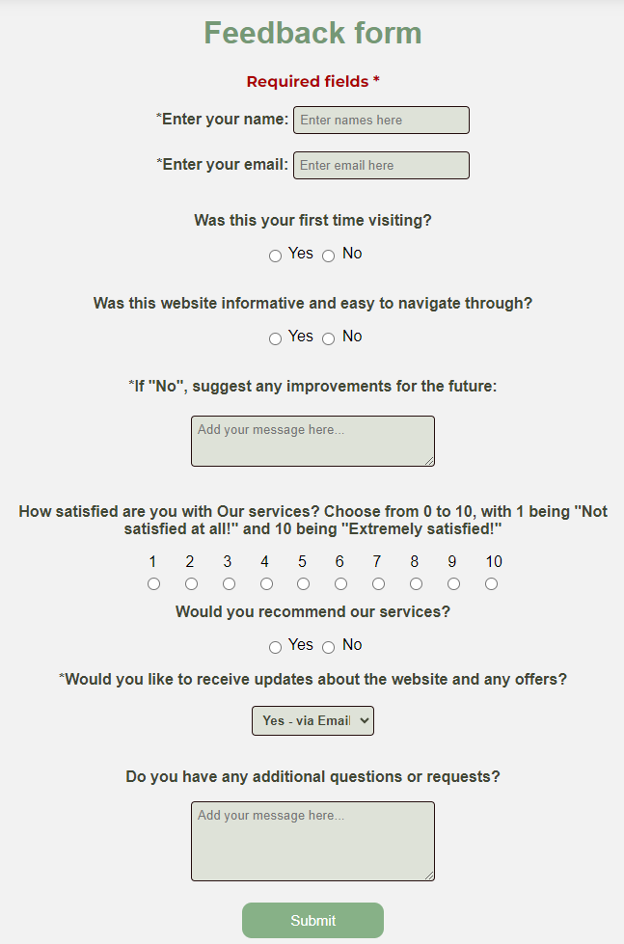

**Figure 10**. Rating and comments form input options

### 3.1.7 Sitemap: Assigned to [**Student 4**]

A sitemap serves as a visual representation of the structure and hierarchy of a website's pages, helping users and search engines navigate its content. Your sitemap should include the following features:

* **SVG**
* **Interactive**
* **Accessible**
* **Responsive**

The sitemap should be developed using **Scalable Vector Graphics (SVG)**. The SVG sitemap will visually depict the hierarchical structure of the website, with parent pages represented as main branches and child pages as sub-branches (see Figure 11).

Each page of the website will be represented by a **node** (circle or rectangle) within the SVG canvas. Nodes are connected by lines (branches) to illustrate the relationships between pages. Each SVG node will be **interactive** by:

* changing colour on hover
* being a link to the corresponding page it represents.

The SVG sitemap will be seamlessly integrated into the website's design, as a standalone page.

The SVG sitemap should be **responsive**, adjusting its scaling to the browser window.

**Accessibility** features such as alt text should be included for each node to ensure that users with disabilities can access and understand the sitemap. Keyboard navigation is supported to provide an alternative method for interacting with the sitemap.

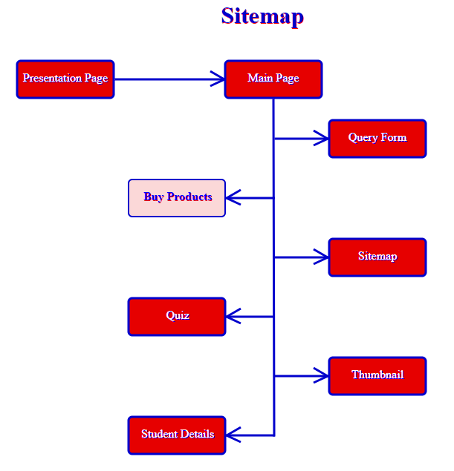 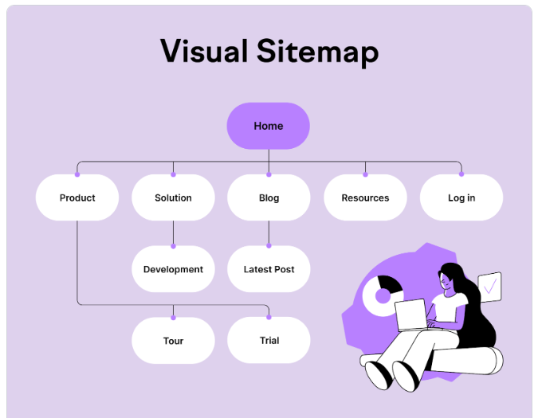

**Figure 11**. Rating and comments form input options

### 3.1.8 Team: Assigned to [**Student 3**]

The team page should include the following elements:

* **Interactive thumbnails**
* **Extended details of thumbnails**

Create a team page to deliver an engaging user experience, enabling users to discover information about the team members who contributed to the development of the website.

Construct the HTML structure for each thumbnail image and its corresponding extended view, following the examples depicted in Figure 12. The thumbnails should support the following interactivity upon hovering:

* The thumbnail image should undergo a visual change, such as altering its alpha value, colour, border or size.
* A box associated with the thumbnail should expand, revealing details about the corresponding team member, including their name, role in the group work, and tasks they were responsible for, similar to the bottom middle image in Figure 12.

Additionally, ensure all images and descriptions have appropriate alternative text for accessibility purposes.

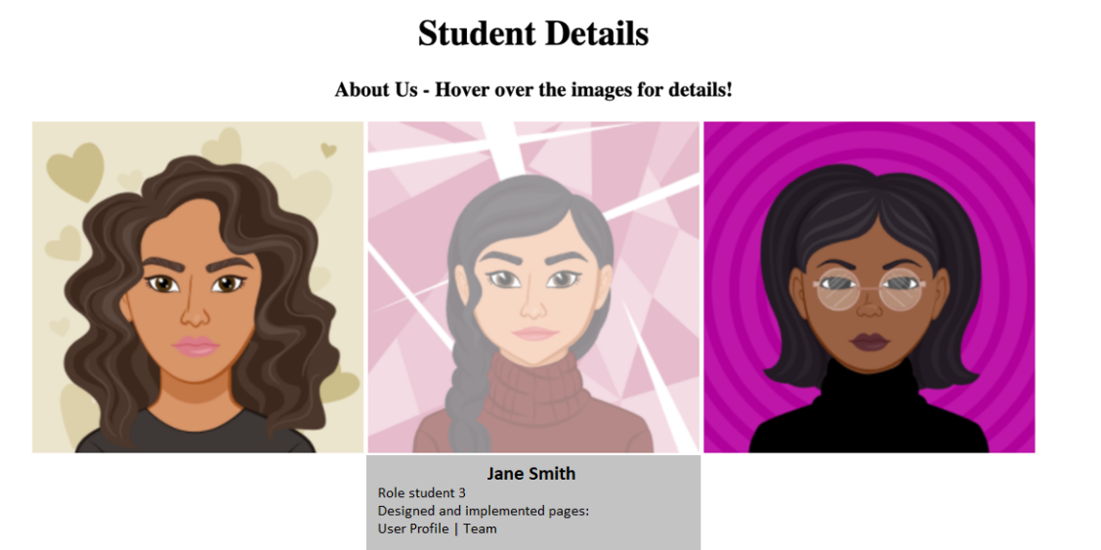

**Figure 12**. An example team page with 3 members (excluding navigation bar, logo and page editor)

### 3.1.9 Content page: Assigned to [**all Students**]

Each team member is responsible for creating an additional content page related to your website's theme/topic (see Figure 13). It's important to ensure that this page has sufficient length to allow for internal linking within the content. For pages longer than the screen size, include links at the top of the page to various sections within the text for easy navigation.

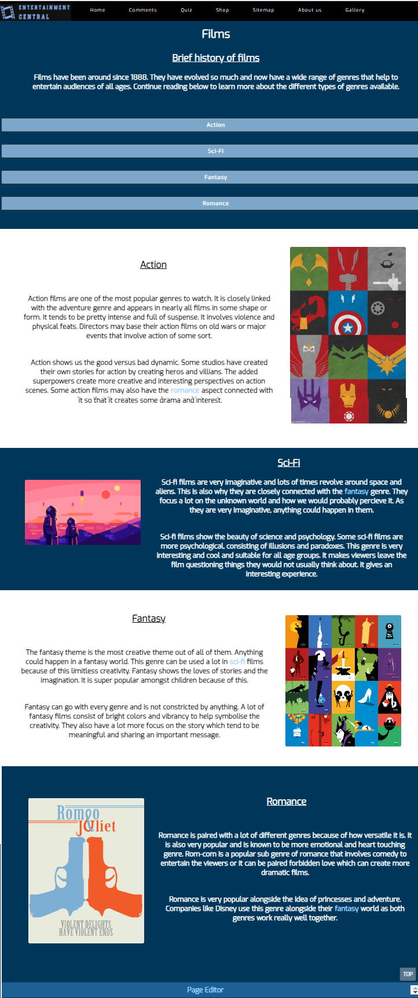

**Figure 13**. An example content page of a website about entertainment

### 3.1.10 Page Editor: Assigned to [**all Students**]

Each team member is tasked with creating an editor’s page. This page will feature your name, role in the group's work, and a list of completed tasks (see Figure 14). This page can be treated as an external page, distinct from the group website, there's no requirement for it to adhere to the main website's design. This provides space for creativity and individual initiative.

You should include a link to this page from all the pages in the website that you created and from the text description of this page there should be also links back to the pages you created.

This page should open in a new tab.

**Figure 14**. A page editor example page that includes descriptions to the completed tasks, links t those pages and internal links

### 3.1.11 Additional JavaScript [**all students**]

Feel free to enhance the website's interactivity and improve navigation by incorporating additional JavaScript functionalities.

### 3.1.12 General coursework requirements [**all students**]

While team members are assigned specific tasks for implementation, it's crucial for the group to collaborate in determining the website's content and overall look and feel.

#### Look and feel

Following this group collaboration, Student 2 will take charge of implementing and providing the following to the rest of the team:

* An **external CSS file that establishes a unified template for the website**. This may include a standardized header featuring the website identity (potentially incorporating a logo and page title), a footer where each team member can include a link to their page editor, and general page styling.
* Development of the **navigation bar** as detailed in section 3.1.2.

**In the event that team members do not contribute ideas for the website's appearance, Student 2 will lead in providing a solution, which the rest of the team will be expected to adhere to. Non-compliance with the template will result in penalties.**

#### Validation

**All pages should be validated with no errors**. Warnings are acceptable. This should be evidenced in your individual report (see report template).

#### Accessibility

**All pages should be validated acceptability.** Compliance of your website for accessibility report can be included as part of your footer. This should be evidenced in your individual report (see report template).

#### Janet regulations on publications

Ensure strict compliance with Janet regulations governing the publication of web pages. Your adherence to these regulations will not only be evaluated based on the completion of your work but also on your ability to demonstrate your understanding and application of these regulations in your report.

### 3.1.13 Website folder structure, file naming [**all students**]

The external CSS file to control the format of the entire website should be saved in the CWK folder with the name: **style.css**

The pages file names should be as follows:

1. **Splash Screen: splash.html** [**Student 1**]
2. **Home Page: home.html** [**Student 2**]
3. **Gallery: gallery.html** [**Student 4**]
4. **Shop: shop.html** [**Student 1**]
5. **User Profile: profile.html** [**Student 3**]
6. **Feedback: feedback.html** [**Student 2**]
7. **Sitemap: sitemap.html** [**Student 4**]
8. **Team: team.html** [**Student 3**]
9. **Content page: student choice** [**all Students**]
10. **Page Editor student choice** [**all Students**]

### 3.1.14 Contribution to Group Meetings

Each group should schedule a minimum of five group meetings (e.g., one per week). Record:

* when/how the meeting was held
* purpose of the meeting
* attendance
* your individual contribution to each meeting

(see template below). This summary should be included in your individual report (see report template). An example is show below.

| Group Coursework Meetings (minimum 5 meetings, e.g., one per week) | | |
| --- | --- | --- |
| 1 | Date & Time | 24 Feb 2024 (online) |
| Objective: | To agree website topic and assign student roles |
| Attended: | All students attended |
| Your Contribution: | I suggested the topic sports with football or tennis as potential options. |
| 2 | Date & Time: | 2 March 2024 (face-to-face) |
| Objective: | Review and agree the design of the home page |
| Attended: | All students attended |
| Your Contribution: | I suggested a colour scheme and layout for the website. |
| 3 | Date & Time: | 9 March 2024 (hybrid) |
| Objective: | Progress meeting |
| Attended: | I did not attend |
| Your Contribution: |  |
| Etc.. | | |

**Students not attending and contributing to group meetings will face penalties as this will affect the team smooth completion of the coursework.**

## 3.2 Individual Report

To successfully complete your individual report, it is essential to utilize the designated **Individual Report Template available on Blackboard**. Each student is required to submit their report using this template, as it offers comprehensive guidance on the report's structure and content. By adhering to the template, students can better understand the requirements of a technical report.

## 3.3 In-class demonstration

Every group must present a mandatory demonstration of their website during the computer seminar class, as scheduled on Blackboard closer to the submission deadline. During the presentation, you will be expected to answer questions regarding the development of your webpage. To do the demonstration, you must integrate all the individual pages in to one complete web application.

**Not-attending the in-class demo will result in penalties.**

## **Coursework Submission**

The submission of the two expected deliverables of this group coursework will be in two steps on Blackboard:

* Step 1 – submit the implemented webpages
* Step 2 – submit the individual report

Both deliverables will be submitted by the same deadline.

To submit your coursework, please ensure all assigned tasks are completed according to the provided instructions in this document.

### 4.1 Step 1 - Website submission

Each student will submit the pages they have been assigned to implement as part of the group coursework in two ways:

* A compressed document containing the files and the folder structure as you worked on those on the local drive. Plus, those webpages in a compressed file. This file should include any CSS files and images located within the folders you've been working on in your local drive.

### 4.2 Step 2 - Report submission

The report will be submitted in a separate link named “**Individual report**” on Blackboard as a word or pdf document.

# Marking scheme

The success of this group coursework hinges greatly on effective collaboration among all team members, with each contributing equally to its completion. Each team member has been assigned tasks of equal level of difficulty, and upon successful completion of all tasks, they are expected to receive a collective coursework mark (as shown in Table 1 below). To ensure fairness and objectivity in evaluating individual contributions to the group coursework, a meticulous marking system has been devised that will be available on Blackboard.

|  |  |  |  |  |  |
| --- | --- | --- | --- | --- | --- |
| **Task** | **Mark** | **Student 1** | **Student 2** | **Student 3** | **Student 4** |
| **Website implementation** |  |  |  |  |  |
| 1 – Splash Screen | 4 | 4 |  |  |  |
| 2a – Home Page + navigation | 7 |  | 7 |  |  |
| 2b – Navigation bar | 3 | 3 | 3 | 3 | 3 |
| 3 – Feedback | 19 |  | 19 |  |  |
| 4 – Shop | 26 | 26 |  |  |  |
| 5 – Sitemap (SVG) | 14 |  |  |  | 14 |
| 6 – Profile | 22 |  |  | 22 |  |
| 7 – Gallery | 16 |  |  |  | 16 |
| 8 – Team | 8 |  |  | 8 |  |
| 9a – Template creation - External CSS | 4 |  | 4 |  |  |
|  |  | 33 | 33 | 33 | 33 |
| 9b – Template use (9a) | 4 | 4 | 4 | 4 | 4 |
| 10 – Content/anchors | 3 | 3 | 3 | 3 | 3 |
| 11 – Page Editor | 2 | 2 | 2 | 2 | 2 |
| 13 – Additional Interactivity | 4 | 4 | 4 | 4 | 4 |
| 14 – Web site integration | 4 | 4 | 4 | 4 | 4 |
| **Subtotal** | | 50 | 50 | 50 | 50 |
| **Individual Report** | 40 | 40 | 40 | 40 | 40 |
| **In-class Demonstration** | 10 | 10 | 10 | 10 | 10 |
|  | **Total** | 100 | 100 | 100 | 100 |

Table 1. The marking scheme for individual tasks assigned to team members